Why was Brazil the last nation to abolish slavery?
Ali Zia

Brazil’s complicated relationship with the institution of slavery has been a compelling aspect of its tense political and social climate from its inception until today. What makes this dynamic even more intriguing is the extensive time taken for Brazil to abolish the slave trade compared to other countries in the Western world. Brazil’s reluctance to join in on a larger abolitionist movement in the 1800s begs the question of why abolition was delayed both socially and in law. While many explanations exist for such a slow removal of slavery, the justification behind Brazil’s slow abolition was ultimately rooted in diplomatic strategy, economic tensions, and religious attitudes.

The surrounding political climate of Brazil both leading up to and during its abolition phase clearly had an impact on Brazilian policymaker’s reluctance to end slavery. Multiple border conflicts with other South American countries, as well as favoritism towards foreign anti-abolition groups, seemed to stifle internal efforts to bring about an end to slavery. For example, conflicts with Uruguay in 1850 exposed the tension between Brazil’s slaveholding society and its neighbors’ abolitionist laws, as Uruguay had already abolished slavery by the 1840s. Brazil’s elite repeatedly pressured Uruguayan authorities to return fugitive slaves, even negotiating treaties that undermined Uruguayan sovereignty and free soil principles (Fischer and Grinberg 139). Even after agreements between Brazil and Uruguay to either return slaves or convert them into paid workers, Brazilian lawmakers continued to interpret laws in the favor of slave masters along the border between the two countries (Fischer and Grinberg 143). Continued tensions between Brazil and Uruguay pushed Brazilian leaders to remain steadfast on the institution of slavery as a way to differentiate from Uruguay’s growing abolitionism. In fact, as Grinberg states, “The abolition of slavery and the subsequent definition of [Uruguay's] national territory as one of free soil” were key to its sovereignty and thus “in opposition to what was seen as Brazil’s expansionist, slaveholding presence” (Fischer and Grinberg 141). To allow for flexibility in abolition was to effectively concede to political enemies such as Uruguay that Brazilian politicians saw as a threat to sovereignty. These diplomatic maneuvers reveal how Brazilian policy abroad was shaped by an interest in preserving domestic laws at the face of foreign threats. Slavery seemed to be a necessary differentiating factor between Brazil and its political adversaries, allowing Brazil to justify the delay in abolition.

These political interests were not only a tool for limiting foreign cooperation. In fact, the role of Brazilian policy in domestic conversations on abolition seemed to slow emancipation efforts even further. The 1871 Free Womb Law appeared progressive but preserved slavery by keeping children born to enslaved mothers in bondage until adulthood (Fischer and Grinberg 12). In reality, it let slaveholders decide whether to free children at age eight or keep their labor until twenty-one (Fischer and Grinberg 12). As a result, this supposedly abolitionist law was held back by the continued dominance of slaveholding interests as “Slavocrats did their best to undermine it, and abolitionists did not consider it adequate” (Fischer and Grinberg 12). Far from liberating enslaved families, the law merely reframed the same conditions under a bureaucratic idea. The registry it required was not aimed at dismantling slavery, but instead enhanced state oversight and facilitated “tax collection on enslaved property” (Fischer and Grinberg 12). These gradual changes seemed to be an effort by the Brazilian government to quell demands for abolition with more state control and surveillance over the slave trade in Brazil itself. These changes also greatly benefitted the political elite who now had greater financial incentives to continue slavery, a problem lamented by Brazilian abolitionists such as Joaquim Nabuco. Nabuco complained that slavery as an institution has had the effect of “servility and irresponsibility for the master caste” (Nabuco 247). Nabuco saw the power gained through slavery as the foundation of elite dominance, calling it a “feudalism” that gave the aristocratic minority control over “the industry, Parliament, the Crown,” and “the entire State” (Nabuco 248). As a result, the Brazilian government’s delay on abolition became its own tool for control over public opinion and even tax policy.

International political dynamics were also shaping Brazil’s hesitation. During the American Civil War, the Empire declared neutrality but granted recognition to the Confederacy, a move that subtly legitimized the Southern slaveholding cause which was paramount to the Confederacy’s formation (Mota 36). The American Civil War not only caused a tension among the Brazilian people regarding how to react, but “it would soon become clear that the conflict’s emphasis on slavery could very well influence the course of abolition” in Brazil itself (Mota 36). Interestingly, the war “became an important reference point for both free and enslaved peoples within Brazil,” so much so that it was cited as a justification for the slave Agostinho’s 1861 organized rebellion in sugar and cotton plantations in the county of Anajatuba (Aguiar 218). This forced the Brazilian government to respond with their own passivity towards the war so as to not incite similar ideas of abolition, while at the same time subtly aiding those who supported continued slavery. The Empire permitted Confederate ships to refuel at Brazilian ports, including the infamous CSS Sumter, which received supplies and hospitality in São Luís in 1861 (Mota 37). Brazilian officials tended to “tread carefully the divide between the abolitionist North and the slaveholding South with which Brazil had so much in common” (Mota 36). This neutrality was seemingly less a position of inactive indifference and more an act of quiet solidarity with a global pro-slavery narrative. Brazil’s overlapping domestic and foreign policy decisions reflected a persistent commitment to slavery at the highest levels, pushing national policy further toward anti-abolitionism rather than the emancipatory stance seen in neighboring countries. In many ways, Brazil’s political loyalty to slavery served to preserve a distinct national identity, one that resisted cooperation with abolitionist neighbors like Uruguay and suppressed internal uprisings, all in the name of maintaining governmental control.

Economics also served as a powerful motivator for continuing the institution of slavery despite domestic and international pressures. The very success and core economic functions of Brazil were heavily dependent on plantation-based farming, meaning that a change to farm labor in the form of emancipation could drastically impact local economies and subsequently the success of the entire state. When investigating the history of Brazil’s coffee trade, for example, the economically strategic support or disapproval of abolition depending on the situation becomes abundantly clear. In the southeast of Brazil, coffee plantations required massive enslaved labor forces and were concerned about “the recruitment of manpower”, especially those in “frontier areas” (Da Costa xxii). In addition, Brazilian elites “were interested in maintaining traditional agrarian structures of production based on slave labor and the latifundio” (Da Costa xxi). After the end of the transatlantic slave trade, the market for slaves boomed as “in the economically stagnant Brazilian Northeast, legions of enslaved people were sold against their will to fuel the labor” in southern coffee plantations (Fischer and Grinberg 10). This placed slavery in the hands of wealthy elites who managed the coffee trade and were “well integrated in the export economy”, suggesting an economic interest in continuing the slave trade for the sake of localized coffee production and subsequent nationwide economic success (Fischer and Grinberg 10). The simple economic advantages of slave labor were enough to convince slave owners to continue in the domestic trade of slaves even after the transatlantic trade was abolished as “coffee, sugar, cotton, and diamonds propelled slave labor to a remarkable level of profitability” (Mota 36). Despite the growing trends of Enlightenment in England and other countries at the time, the elites “opposed attempts to promote industrial development” and abolition due to a dependence on physical slave labor (Da Costa xxi).

Efforts to resolve labor shortages after emancipation further reveal the economic motives behind slavery itself. After abolition, elite concerns about wealth and labor quickly overshadowed any push for justice or reconstruction. Just days after the 1888 Golden Law, lawmakers began proposing legislation to compensate former slaveholders, with over seventy-nine attempts raised in Congress within months (Chazkel 69). This made clear that elite political energy was being redirected toward securing property claims rather than resolving the crisis of labor shortages or supporting the newly freed population. Notably, Rui Barbosa, a Brazilian lawyer and abolitionist, burned slave records after abolition to prevent slave owners from making compensation claims, again reinforcing the ties between economic motivations and wanting to delay emancipation (Chazkel 73). As Chazkel notes, slave owners “came to focus their efforts on a small indemnity...to appear that they were fighting not for their economic self-interest, but rather for fundamental principles” (Chazkel 68). Elites continued to argue for compensation, with one official noting that to deny indemnification was to “negate, deliberately, the principle of property” (Chazkel 68). Those plantation owners who were open to immigrant labor rather than slavery tended to already own many slaves, furthering the notion that accepting or rejecting abolition was heavily based on resources (Da Costa xxv). This suggests that the urgency to address economic disruptions for slaveholders consistently took precedence over advancing abolitionist reforms. This clear superiority of economics over a moral stance on slavery seemed to be key in abolition’s delay across Brazil, defining the attitudes of slave owners while troubling the campaigns of Brazilian abolitionists.

Aspects of the Brazilian Church and religious narratives also played a role in stalling efforts on abolition. Many political thinkers in Brazil blamed the Church’s complicity in slavery for the spiritual decay of masters and slaves and the brutal continuation of the institution. Joaquim Nabuco’s argument against Brazilian slavery points out the fact that “the abolitionist movement unfortunately owes nothing to the state church” because “the ownership of men and women by the convents” was something that “completely demoralized the religious feelings of masters and slaves” (Nabuco 249). In fact, “no priest ever tried to stop a slave auction; none ever denounced the religious regiment of the slave quarters” and The Catholic Church “never raised its voice in Brazil in favor of emancipation” (Nabuco 249). These statements suggest that popular religious sentiment around slavery in Brazil took a pacifist route, which stifled internal efforts to find a larger moral justification to put a stop to injustice. Nabuco notes that this was starkly different to the abolition campaigns of other countries, which, given the political reasons for Brazil’s delay in emancipation, could be related to an existing desire to differentiate from political enemies. This is most strongly supported by Nabuco’s note that “in other countries the propaganda of emancipation was religious, preached from the pulpit” yet “in Brazil, it was a political movement” focused on economies of labor (Nabuco 240). Even abolitionist thinkers such as José Bonifácio, for example, asked “why is it only the Brazilians who continue to be deaf to the cries of reason” and “the Christian religion”, suggesting that even dissent against slavery constantly faced the problem of religious ignorance (Bonifácio 2). Unlike the American Civil War, which drew on Christian doctrine to support abolition, Brazil’s religious stance on slavery was largely detached, and when religion was used in resistance, it was quickly suppressed. This is most evident in Afro-Brazilian religious expression regarding abolition. The 1835 Malê Revolt, an uprising of African-born Muslim slaves and freedpeople in Bahia, was quickly stifled with many being punished, deported, or forced to flee Brazil altogether (Reis 184). Similarly, the Afro-Brazilian religion Candomblé, rooted in Nigerian Yoruba tradition, was branded immoral and superstitious as it unified enslaved and free Africans against slavery. Authorities carried out raids on religious gatherings and labeled them “pernicious ideas” that had to be extinguished to maintain social order (Day 11). As a result, religion, especially the suppression of religion and pacifism, were essential in ensuring that slavery in Brazil would persist longer than its neighboring nations, even those that inspired its secularization.

While some may argue for a a resounding social backlash to slavery in Brazil and that the delay in abolition was an issue of chance and circumstance, the aforementioned efforts of monarchist abolitionists such as Joaquim Nabuco, Rui Barbosa, and José Bonifácio suggest that political, economic, and religious factors were enough to stifle both philosophical rebuttals of slavery and small-scale military revolts. Fear of foreign influence, economic loss, and suppressed faith not only stalled abolition but also shaped the system that sustained slavery, with its legacy defining race and class in modern Brazil.

Works Cited

Aguiar, Francisco Primo de Souza. “The U.S. Civil War and Slave Rebellions in Brazil.” The Brazil Reader: History, Culture, Politics, edited by James N. Green, Lilia Moritz Schwarcz, and Victoria Langland, 2nd ed., Duke University Press, 2018, pp. 218–219.

Bonifácio de Andrada e Silva, José. “On Slavery.” The Brazil Reader: History, Culture, Politics, edited by James N. Green, Lilia Moritz Schwarcz, and Victoria Langland, 2nd ed., Duke University Press, 2018, pp. 173–176.

Chazkel, Amy. “History out of the Ashes: Remembering Brazilian Slavery After Rui Barbosa’s Burning of the Archive.” The Destruction of Archives in Latin America, edited by Carlos Aguirre and Javier Villa-Flores, Editorial Contracorriente, 2015, pp. 61–79.

Costa, Emília Viotti da. The Brazilian Empire: Myths and Histories. University of Chicago Press, 1985.

Fischer, Brodwyn, and Keila Grinberg, editors. The Boundaries of Freedom: Slavery, Abolition, and the Making of Modern Brazil. Cambridge University Press, 2023. Introduction, pp. 1–32; and Chapter 5, “The Abolition of Slavery and International Relations on the Southern Border of the Brazilian Empire, 1840–1865,” pp. 128–159.

Mota, Isadora Moura. “Other Geographies of Struggle: Afro-Brazilians and the American Civil War.” Hispanic American Historical Review, vol. 100, no. 1, Feb. 2020, pp. 35–62.

Nabuco, Joaquim. “Selections from Abolitionism.” The Brazil Reader: History, Culture, Politics, edited by James N. Green, Lilia Moritz Schwarcz, and Victoria Langland, 2nd ed., Duke University Press, 2018, pp. 246–247.

Reis, João José. Divining Slavery and Freedom: The Story of Domingos Sodré, an African Priest in Nineteenth-Century Brazil. Cambridge University Press, 2015, pp. 1–74.

Reis, João José. “The Malê Revolt.” The Brazil Reader: History, Culture, Politics, edited by James N. Green, Lilia Moritz Schwarcz, and Victoria Langland, 2nd ed., Duke University Press, 2018, pp. 184–187.

Subpoint 1 - Political/diplomatic reasons
- The Abolition of Slavery and International Relations on the Southern Border of the Brazilian Empire, 1840–1865 Keila Grinberg*
  - Power of the elite
  - Uruguay
- Selections by Nabuco
  - Power of the elite
- Introduction Slavery and Freedom in Nineteenth-Century Brazil
  - The monarchy deliberately delayed full abolition to avoid political upheaval. Even the 1871 Free Womb Law was designed to appear progressive while preserving slaveholders' interests
- Other Geographies
  - Brazil’s official neutrality during the American Civil War — while maintaining diplomatic relations with both the Union and the Confederacy — highlights how the Brazilian Empire tried to avoid aligning itself with any anti-slavery stance:
  - “Emperor Pedro II declared Brazil’s neutrality... carrying on diplomatic relations with the Washington government and conceding belligerent status to the Confederacy.”
  - “Brazil... tread carefully the divide between the abolitionist North and the slaveholding South with which Brazil had so much in common.”
  - “Brazilian authorities... responded dubiously to Semmes’s call for unity [between Confederacy and Brazil], but granted his ship port entry and provisioning.”
Subpoint 2 - Economic reasons
- The Abolition of Slavery and International Relations on the Southern Border of the Brazilian Empire, 1840–1865 Keila Grinberg* (briefly)
- Introduction Slavery and Freedom in Nineteenth-Century Brazil
  - Coffee plantations in the Southeast (Rio, São Paulo, Minas Gerais) required massive enslaved labor forces. After the 1850 end of the Atlantic trade, a brutal internal slave trade surged, displacing thousands from the Northeast
  - Elites viewed abolition as a threat to property and labor supply, and they opposed reforms that could undermine the export economy
  - Only when economic conditions shifted—e.g., the threat of labor shortages and desire for European immigrants—did even conservative coffee planters begin to favor abolition, but only to preserve their own productivity
- Da Costa’s introduction:
  - 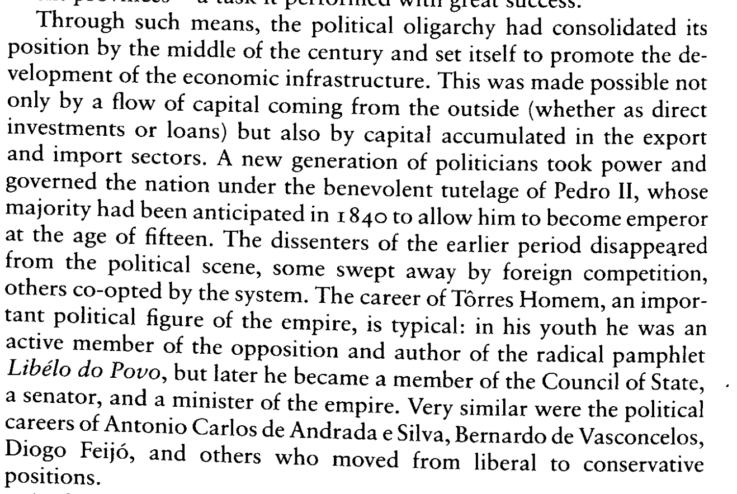(xxii)
  - 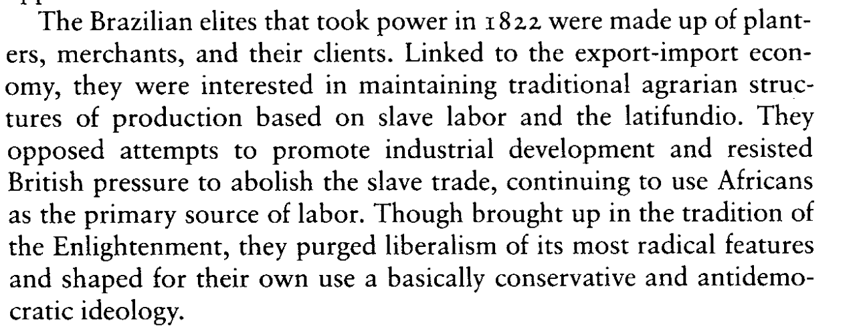(xxi)
  - 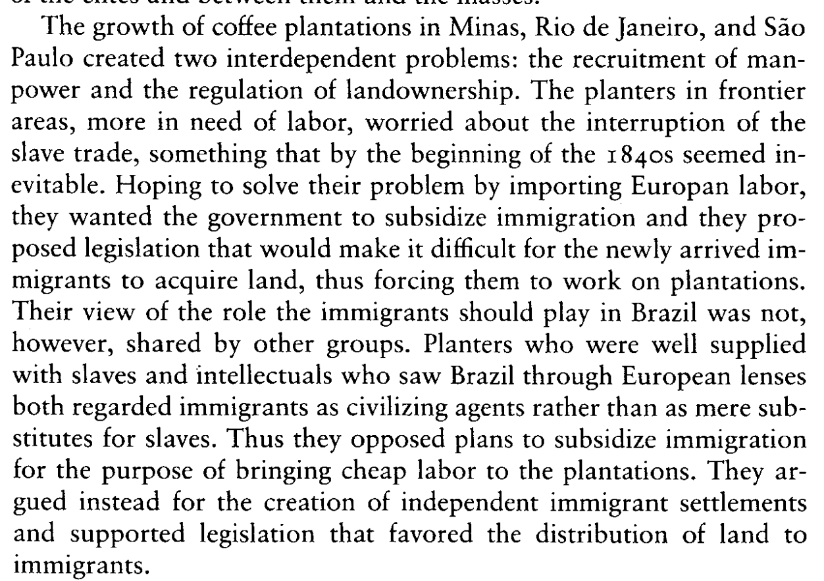(xxv)
- Page 66 of Chazkel
  - “The most controversial question involved whether former slave owners... would receive monetary compensation for their loss.”
  - “Abolishing slavery without indemnifying the proprietors would be to negate, deliberately, the principle of property.” (p. 68)
  - Barbosa burned the documents on slavery because:
To prevent former slaveowners from claiming compensation (“indemnification”) for the loss of their enslaved people after slavery was abolished in 1888. He feared these claims would be a burden on the new Republic’s finances. He also believed that recognizing those claims would legitimize human ownership.
Subpoint 3 - Religious reasons? Control of the church
- Selections by Nabuco
  - 🔹 Church Complicity in Slavery
  - “Among us the abolitionist movement unfortunately owes nothing to the state church. On the contrary, the ownership of men and women by the convents and by the entire secular clergy completely demoralized the religious feelings of masters and slaves.”
🔹 Moral Failure of the Clergy
  - “No priest ever tried to stop a slave auction; none ever denounced the religious regiment of the slave quarters... The Catholic Church... never raised its voice in Brazil in favor of emancipation.”
🔹 Contrast with Other Countries
  - “In other countries the propaganda of emancipation was religious, preached from the pulpit... In Brazil, it was a political movement... born of a different purpose: the hope of reconstructing Brazil on the basis of free labor.”
  - Sodres Day:
  - The text shows how Candomblé (Afro-Brazilian religion) was persistently repressed by the state, press, and police. It was seen as superstitious, immoral, and un-Christian.

  - African religious gatherings were raided, worshippers jailed, and practices demonized.

  - Chief João Henriques labeled Candomblé a threat to "morality and civilization", especially as it spread beyond enslaved Africans to free Black and mixed-race Brazilians:

  - “Candomblé was nothing but a jumble of superstitious beliefs controlled by conmen who exploited the ignorants—particularly women—but now... their victims also included... well-educated citizens.”

  - “It was necessary to suppress 'pernicious ideas' that led to allegedly pernicious practices...”
  - Male Revolt?
Counter - There was religious and social backlash to the institution of slavery, but it could not override the power of the other facts of society that reinforced it
- Bring up the primary source documents from the brazil reader

Conclude

